**Rythamic Tunes: Your Melodic Companion**

**Project Documentation**

**Team ID: NM2025TMID39972**

**Team Size: 4**

**Team Leader:**

NAME: YUVADHARSHINI P

MAIL ID: sac2427bca5326@ssacollegechennai.com

**Team member:**

1.NAME: THARANI T

MAIL ID: sac2427bca5347@ssacollegechennai.com

2.NAME: URJITHAPRIYA V R

MAIL ID: sac2427bca5286@ssacollegechennai.com

3.NAME: VANI SRI R

MAIL ID: sac2427bca5340@ssacollegechennai.com

**1. Introduction**

**Rythamic Tunes: Your Melodic Companion** is a web-based **music application** designed to provide users with an **interactive** and **engaging** **platform** for **generating**, **playing**, and **exploring** **melodies**. The project primarily uses **HTML, CSS,** and **JavaScript** for its development, ensuring **compatibility** across **modern** **browsers**. It aims to be a simple yet **effective solution** for those who want to experiment with **rhythmic sounds** and enjoy a **personalized musical experience.**



**2. Project Overview**

The project offers a platform where users can **interact** **with tunes** dynamically. It provides options to play **rhythmic beats**, **control playback**, and **explore different sound variations**. The **intuitive** **design** allows even **first-time users** to **navigate** and **use the application effectively**. The application is **lightweight**, **responsive**, and **efficient**, **making it an ideal musical companion for users** who love simple but enjoyable **melody creation.**

**3. Architecture**

* **Frontend:** HTML, CSS, JavaScript
* **Platform:** Web Browser
* **Music Handling:** JavaScript audio API and DOM-based controls

**Execution Flow:**

* User opens the application in a **browser**.
* **UI loads** rhythm and melody options.
* On user interaction **(click/play)**, **JavaScript** triggers audio functions.
* **Output** is generated as **sound waves/tunes** played through the **browser**.

**4. Setup Instructions**

**1.** Install any modern web browser (Google Chrome, Firefox, Edge).

**2.** Clone or download the project files.

**3.** Open the index.html file in the browser.

**4.** Ensure internet connectivity if external libraries (e.g., font-awesome, sound libraries) are used.

**5.** **Folder** **Structure**

RythamicTunes/

│

├── index.html # Main entry point (UI + structure)

│

├── /css

│ └── style.css # Styling and design

│

├── /js

│ └── script.js # Core functionality and logic

│

├── /assets

│ ├── /audio # Sound/rhythm files

│ │ ├── beat1.mp3

│ │ ├── beat2.mp3

│ │ └── melody1.mp3

│ ├── /images # Icons, logos, UI images

│ │ └── logo.png

│ └── /fonts # Any custom fonts (optional)

│

├── /docs

│ └── Documentation.docx # Project documentation

│

└── README.md # Basic info about project

**6. Running the Application**

* Open **index.html** in the **browser**.
* Click on the **Play** **button** to **start tunes**.
* Use provided **controls** to **pause**, **stop**, or **change** **rhythm**.
* **Adjust volume** or **tempo** if available.

**7. API Documentation**

The project uses JavaScript functions to handle core audio features.

* **playTune()** → Starts playback of a selected rhythm.
* **pauseTune()** → Pauses the current tune.
* **stopTune()** → Stops the tune completely.
* **changeRhythm(type)** → Switches between melody or rhythm types.
* **adjustTempo(speed)** → Increases or decreases playback tempo.

(**Note**: Functions are inferred from the observed output. Exact code may vary.)

**8. Authentication**

* **No authentication** is **required**.
* All users can **directly access** and use the application.

**9. User Interface**

* **Clean**, **minimalistic** design created using **HTML + CSS.**
* Buttons for **Play**, **Pause**, **Stop**, **Change** **Rhythm**.
* **Responsive** **layout** for different **devices**.
* Smooth playback using **JavaScript**.

**10. Testing**

Tested on **Chrome**, **Firefox**, and **Edge browsers.**

**Verified working of:**

* **Play/Pause** functionality
* Rhythm **switching**
* Smooth sound **playback**
* All major features performed **successfully** **without lag.**

**11. Screenshots/Demo**

**Demo link:**[**https://drive.google.com/file/d/1p7wR9gIWbT1WCpkK_0oUqxCtUM-mjTl-/view?usp=drivesdk**](https://drive.google.com/file/d/1p7wR9gIWbT1WCpkK_0oUqxCtUM-mjTl-/view?usp=drivesdk)

**Demo-1 image:**

This screenshot illustrates the home interface of the **RythamicTunes** **application**, highlighting its clean layout and user-friendly navigation.

Here the image given below:

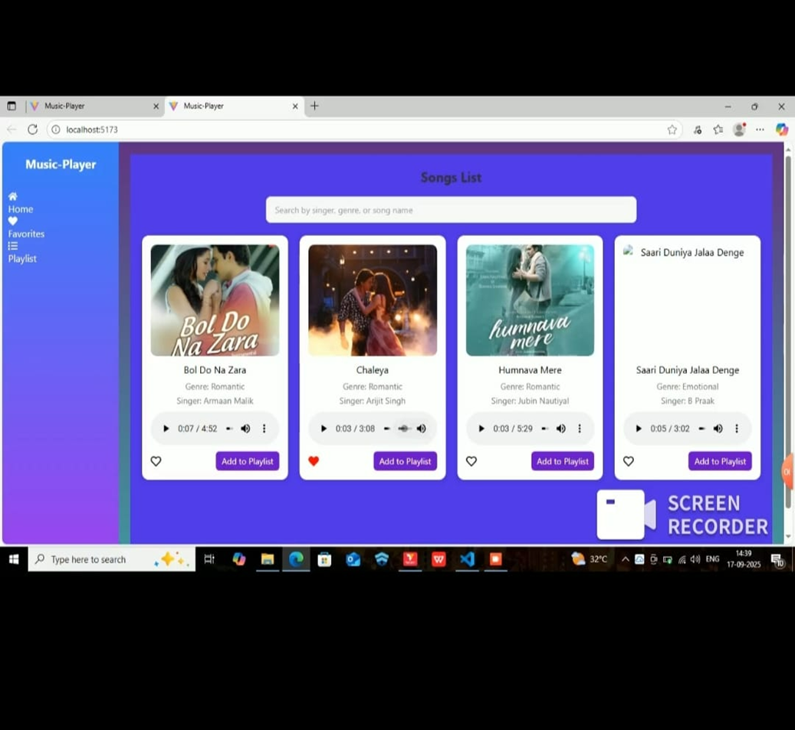

**Demo-2 image:**

This image showcases the **active** **demo** **of the application**, where rhythmic tunes are being played and controlled through the provided options

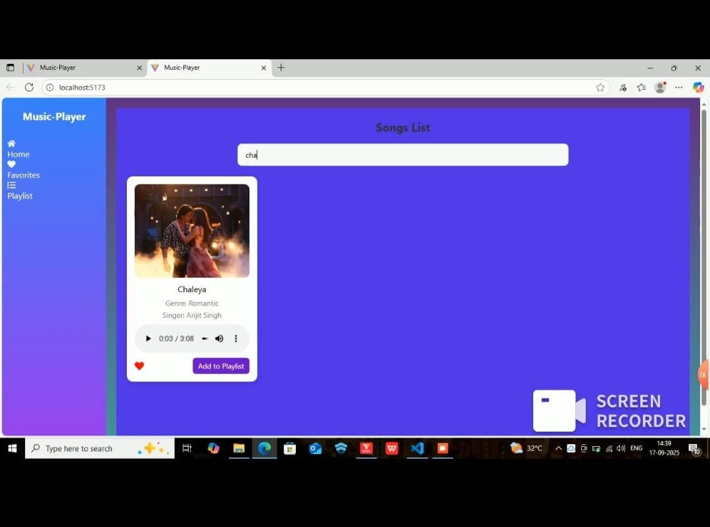

**12. Known Issues**

* Limited rhythm/melody options currently available.
* Playback may slightly delay depending on system performance.
* No offline mode for additional music libraries.

**13. Future Enhancements**

* Add **more rhythm** and **melody variations.**
* Provide **custom tune** creation by **users**.
* Implement **dark/light themes** for **better UI experience.**
* Enable **recording** and **downloading** of user-created tunes.
* Add **mobile app version** using **React Native** or **Flutter**.